A) **Names**

Hon Guang Yu Jeremy A0127572A

Ken Lee Shu Ming A0125546E

B) **Frequency**

650 Hz

C) **Charts**

**Sample A Chart**

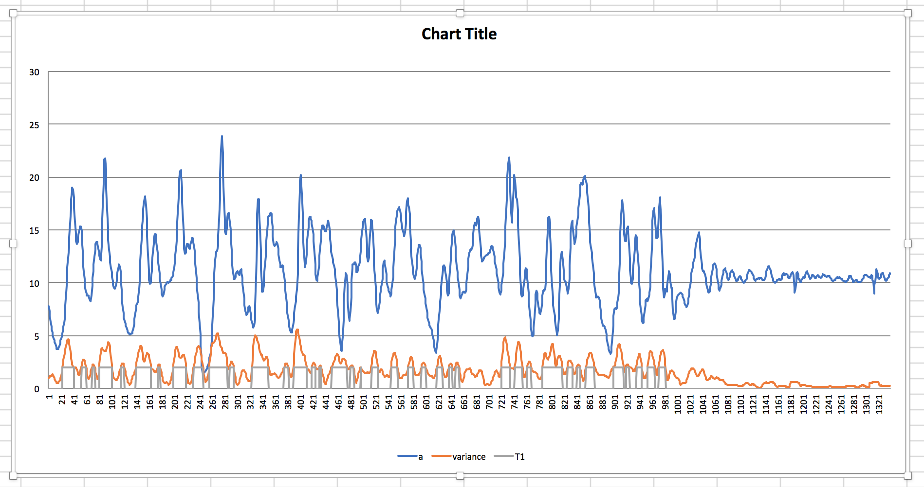

**Sample B Chart**

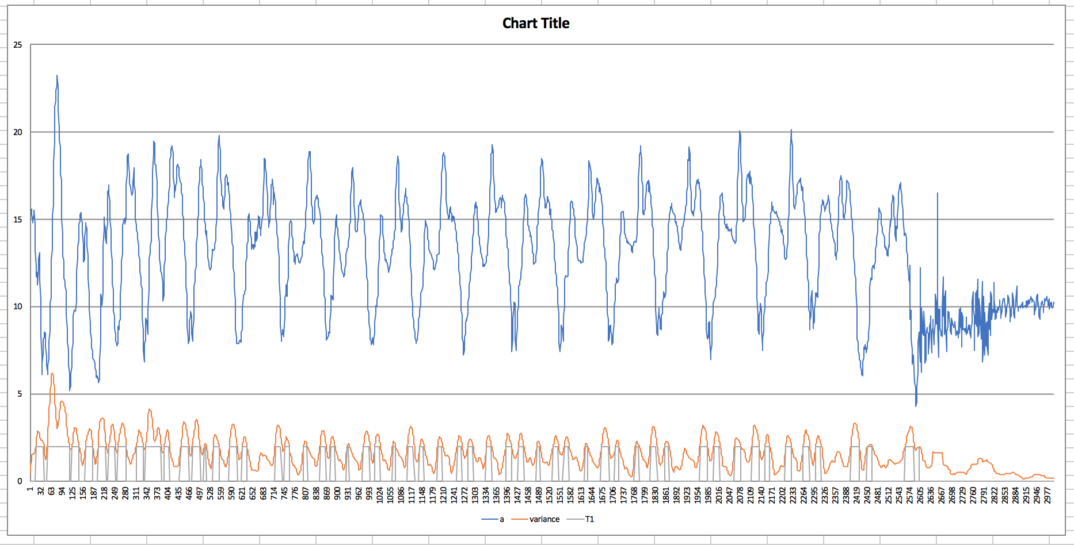

D) **Ground Truths**

Sample A: 37 Steps

Sample B: 20 Steps

E. **The algorithm**

The algorithm used is the step counting algorithm which uses thresholding to detect steps.

The T1 value that we have chosen is 2, and the window size is 15. However, our window size should grow as the frequency of the data collect increases.

We also understand that our algorithm sometimes double count steps as seen in the chart above, where the T1 drops to 0 and back to a high value immediately. The issue can be mitigated by setting a minimum time threshold between each step (data suggests around 0.3s). However, in order to implement this, we will need to obtain the data sampling rate, which is not provided.

F. **Accuracy**

In sampleA, our counter has six false positive steps (due to double counting) and five false negatives out of 37.

In sampleB, our counter has fourteen false positive steps (due to double counting) and two false negatives out of 20.